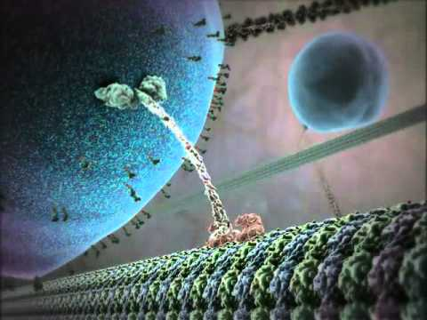 AP Biology: Assignment Checklist for November 12 – 25 2018

Topic Descriptions | Focus, Instructions and Links | Due Dates
Ch. 2 The Chemical Context of Life | Focus: Remind yourself of basic chemistry such as structure of an atom, types of bonds and interactions.  Being able to predict and apply the properties of molecules will contribute to your success. Memorizing molecules is not necessary but understanding the properties allows you to predict their behavior.  In this chapter we will apply isotopes in radioactive dating.  Mastering biology is due on 11/12 by 11:59, no exceptions. With any MB assignment, if you score 90% or better on the main assignment, you automatically earn the Adaptive Follow-up points. If you score less than 90% then you will do 2 sets of adaptive follow-up questions.  Be able to answer questions 1-9, pg 42-43, on a quiz that will cover chapters 2 and 3. | 11/12/18 by 11:59
*Ch. 3 Water and Life | Water is essential to life is one of the major compounds astronomers look for on planets.  Read chapter 3. What are the properties of water AND why does water exhibit these properties.  Think about polar covalent bonds between the Hs and O in a water molecule.  MB Ch. 3 is due Thursday, 11/15 by 11:59 pm  Be able to answer questions 1-6 pg 55 on a quiz that covers chapters 2 and 3 | 11/15/18 by 11:59 pm
*Ch. 4 Carbon and the Molecular Diversity of Life | Ch. 4 focuses on the role of carbon in forming organic molecules. What is the structure of carbon? How many valence electrons does it have? Does it form covalent or ionic bonds?  Read the chapter carefully and do MB Ch. 4: due 11/18/18, 11:59pm  When we get to this chapter we will discuss the properties of functional groups. This will be followed by a quiz the following bell. Are these groups polar or nonpolar? How does impact the behavior of organic molecules? | 11/18/18, 11:59pm
*Ch. 5 The Structure and Function of Large Biological Molecules | Ch. 5 is about organic molecules. When we are done you should be able to recognize a carb, lipid, protein, and nucleic acid when you see them and therefore you should be able to predict their properties by the presence and location of the functional groups.  Do MB, Ch. 5, due 11/21/18 by 11:59pm | 11/21/18 by 11:59pm

*Bozeman Science videos and Quizzizz will be assigned as we go.

