Label each cell as a plant cell, an animal cell or a bacterial cell.
Label the following (if present) on the diagrams:

Cell junctions
Cell wall
Chloroplast
Cytoskeleton
Flagella and Cilia
Golgi Body
Lysosome
Mitochondria
Nucleolus
Nucleus
Plasma membrane
Pilli
Ribosome
Rough endoplasmic reticulum
Smooth endoplasmic reticulum
Vacuole

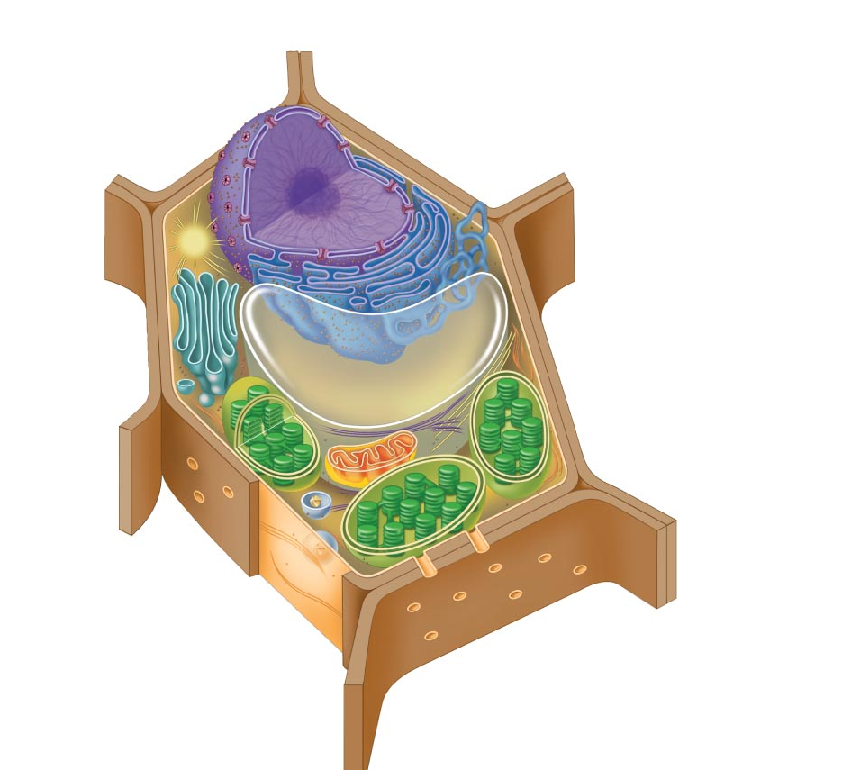
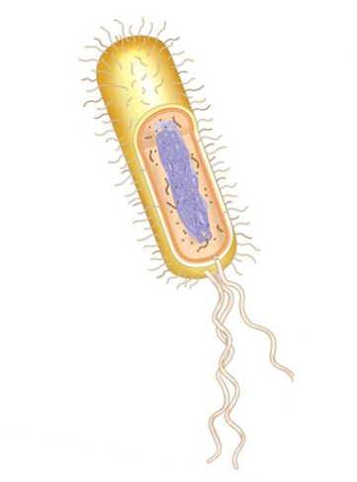

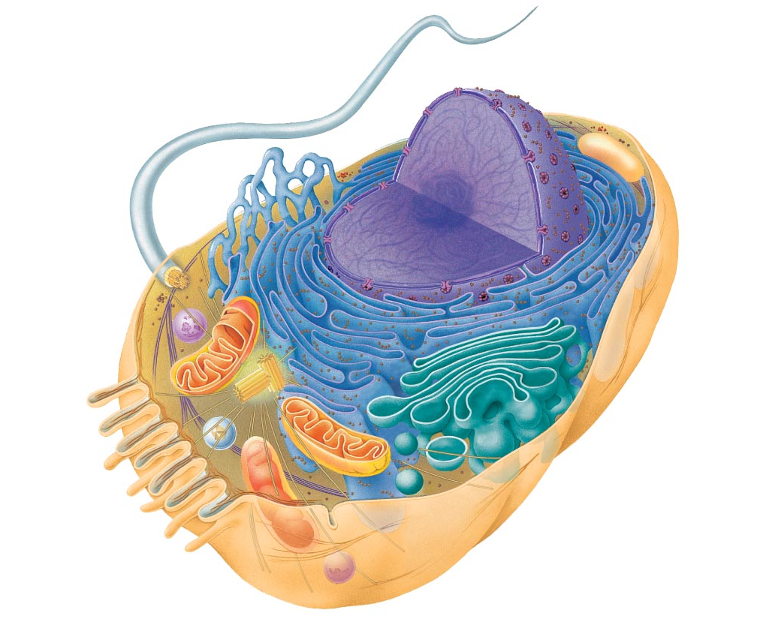

Cellular Organelles & Sub-Cellular Components: Structures and Functions

Cell Component  (drawing or picture) |  | Details | Present In??  Prokaryotes  Plants  Animals | Visible under light microscope?
Plasma membrane |  | Location:  Function:
Cell wall |  | Location:  Function:
Ribosome |  | Location:  Function:
Cell Component  (drawing or picture) | Details |  | Present In??  Prokaryotes  Plants  Animals | Visible under light microscope
Mitochondria | Location:  Function:
Chloroplast | Location:  Function:
Rough Endoplasmic Reticulum | Location:  Function:
Cell Component  (drawing) | Details |  | Present In??  Prokaryotes  Plants  Animals | Visible under light microscope
Smooth Endoplasmic Reticulum | Location:  Function:
Lysosome | Location:  Function:
Vacuole | Location:  Function:
Cell Component  (drawing or picture) | Details |  | Present In??  Prokaryotes  Plants  Animals | Visible under light microscope
Nucleus | Location:  Function:
Nucleolus | Location:  Function:
Centrioles | Location:  Function:
Cell Component  (drawing) | Details |  | Present In??  Prokaryotes  Plants  Animals | Visible under light microscope
Golgi Body | Location:  Function:
Cilia  Flagella | Location:  Function:  Location:  Function:
Peroxisomes | Location:  Function:
Cell Component  (drawing) | Details |  | Present In??  Prokaryotes  Plants  Animals | Visible under light microscope
Cytoskeleton | Location:  Function:  Structure:  Microtubules  Microfilaments  Intermediate Filaments
Cell Junctions  Tight junction  Gap junction  Desmosome  Plasmodesmata | Location:  Function:

Credited to Ms Foglia CELL ORGANELLES and modified by DAllen
Explain how the following organelles work together to perform the life functions of the cell
1. Nucleus and ribosomes
___________________________________________________________________________
___________________________________________________________________________
___________________________________________________________________________
___________________________________________________________________________
___________________________________________________________________________
2. Endoplasmic reticulum and Golgi bodies
___________________________________________________________________________
___________________________________________________________________________
___________________________________________________________________________
___________________________________________________________________________
___________________________________________________________________________
3. Endoplasmic reticulum and ribosomes
___________________________________________________________________________
___________________________________________________________________________
___________________________________________________________________________
___________________________________________________________________________
___________________________________________________________________________
4. Golgi bodies and lysosomes
___________________________________________________________________________
___________________________________________________________________________
___________________________________________________________________________
___________________________________________________________________________
5. Nucleus and endoplasmic reticulum
___________________________________________________________________________
___________________________________________________________________________
___________________________________________________________________________
___________________________________________________________________________
6. Endoplasmic reticulum and Golgi bodies and vesicles
___________________________________________________________________________
___________________________________________________________________________
___________________________________________________________________________
___________________________________________________________________________
7. Endoplasmic reticulum and cell membrane
___________________________________________________________________________
___________________________________________________________________________
___________________________________________________________________________
___________________________________________________________________________

8. Compare and contrast the following types of microscopes: Compound light microscope, SEM, and TEM.
___________________________________________________________________________
___________________________________________________________________________
___________________________________________________________________________
___________________________________________________________________________
___________________________________________________________________________
___________________________________________________________________________
___________________________________________________________________________
___________________________________________________________________________
___________________________________________________________________________
___________________________________________________________________________
___________________________________________________________________________

9. Describe the relationship of surface area to volume. What is the importance of the surface area to volume ratio for cells?
___________________________________________________________________________
___________________________________________________________________________
___________________________________________________________________________
___________________________________________________________________________
___________________________________________________________________________
___________________________________________________________________________

10. Describe the major differences between animal and plant cells.
___________________________________________________________________________
___________________________________________________________________________
___________________________________________________________________________
___________________________________________________________________________
___________________________________________________________________________
___________________________________________________________________________

Objectives:
Big Idea 2: Biological systems utilize free energy and molecular building blocks to grow, to reproduce and to maintain dynamic homeostasis. EU 2B: LO 2.10-2.14

Helpful Websites:
Cells Alive (cellsalive.com)
The Biology Project (www.biology.arizona.edu) Cell Biology section lots of information here

